**CHAPTER ONE**

**1.1 Introduction:**

The mass development in the computers and internets in the world, And entry in all areas so that has become everything in our world depends on the technology and the increasing demand of people on food provided by restaurants for ease and speed of what they offer should be for technology a key role in facilitating these operations, speed and management of applications for external operations with ease.

**1.2 Problem Statement**:

The increase in demand quickly and easily become an obstacle in the face of a lot of these sites where users are demanding increasing demands speed, reliability and ease PDF applications costs and I restaurant owners are demanding easily issuing reports, this was one of the biggest obstacles to these sites electronic and software that rely on programming languages may be slow or unsafe with the difficulty of finding a user interface and easy-to-friend.

**1.3 Project motivation:**

Do work Website to provide outdoor dining requests so that it is inclusive for all restaurants be easy to use so that allows the user to know all the information required in terms of price and the components of this food and have security in terms of ways to pay for applications and get the best deals and to enjoy the site speed and efficiency that will satisfy the customer and the restaurant owner.

**1.4 Related works:**

In this section, we conduct analysis of some of the software and find the positives and the problems and the work of comparisons between these sites. [1]

**1.4.1 Talabat :**

This is the strongest in the Arab world, the site from which the customer requested food and payment upon delivery of the request of the problems in this slow-site operations and process that interfaces is user-friendly payment methods as unsafe. [2] see figure(1)

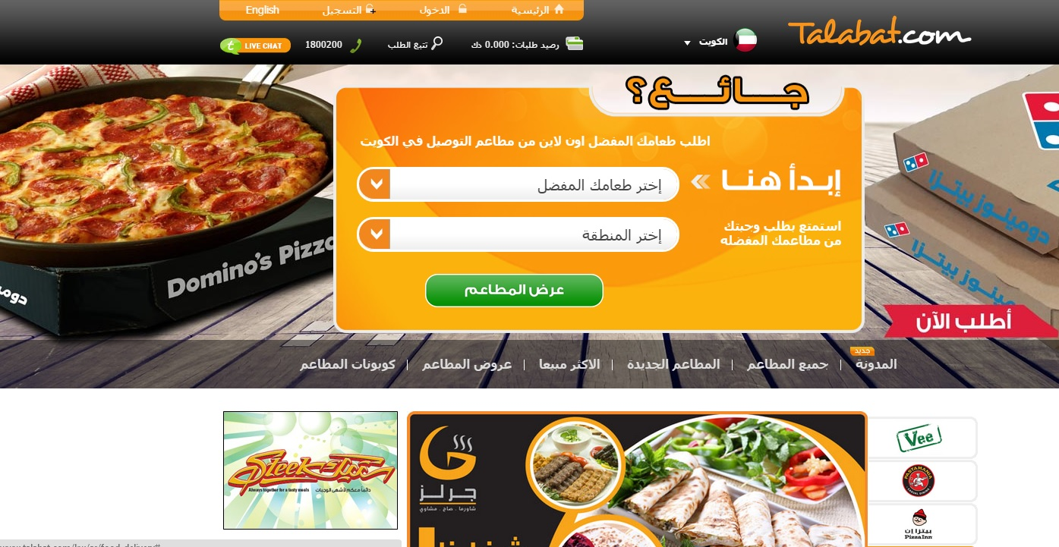 figure(1):talabat.com

**1.4.2 Foodonclik:**

Arabic site features quickly navigate between pages, but the facades of difficult and payment methods which are unsafe and depends on the material gain for registration.[3] see figure(2)

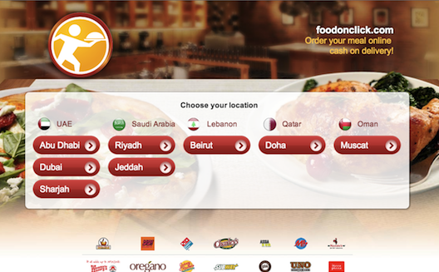figure(2): Foodonclik

**1.4.3 food_zilla:**

Arabic site fast browsing between pages and interfaces but are not flexible on all screens, such as mobile and tablet screens.[4] see figure(3)

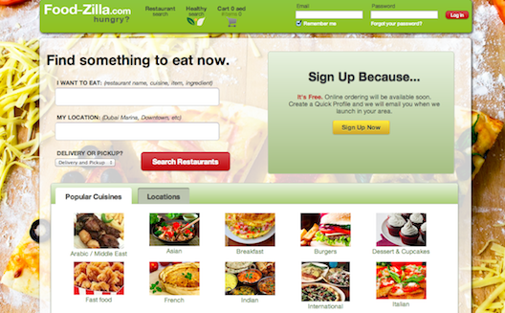

figure(3): food_zilla

**1.5 Methodologies:**

After some previous systems analysis and find the positives and disadvantages and problems we have to develop an action plan for the work site operation be easy for the user and has an all additions that could be needed by the customer or the owner of the restaurant mindful of speed beautiful shape, bright colors in order to attract everyone to the site, and then do a test site so that we operations development him and take the feedback to customers and restaurant owners.[5]

**CHAPTER TOW**

**2.1 Introduction :**

Software design describes the features and operations of the intended application in detail, including screen layouts, business rules, process diagrams, which programs are needed, and how are they going to interact. Within this phase the architectural design, detailed design, interface design, and data design are discussed in depth. Different types of diagrams and models are used to illustrate those designs, as detailed in the following sections.

Requirements engineering (RE) process is the process of determining what the system should provide (functional requirements) in addition to the constraint of the system behaviors (nonfunctional requirements). [6 ]

Many approaches had been followed to collect the requirements of the proposed system. These approaches include:

1. Surveying the literature for similar systems in order to define the functions and facilities that the proposed system should provide. In addition, to determine the weakness in the current systems to be avoided it in the proposed system.

2. Brain storming: many meetings had been conducted among team members to find out some additional functionality that can be provided by the proposed system.

3. We had several discussions with Mr. Mohmad Manasrah,developer in STS . We gathered from him all the information we needed in this project. We have used his system and detected some errors and problems in the system. On the other hand, we also discussed with the project supervisor Dr. abd alslam obiedat ideas on implementing our system and how to manage and integrate the systems process to each other.

**Functional requirements::2.2**

**System Functional Requirements: 2.2.1**

In this proposed project there are many functional requirements as follow:

1 . The system should interact with four user group; Admin (Owner), Customer.

2. That the customer offer meals and modify them according to his desire.

**2.2.2 : Admin(Owner) Functional Requirements:**

Administrator is the user who is responsible for configuration of all the system parameter:

1. The system should allow administrator to add new meal.

2. The system should allow administrator to update meal.

3. The system should allow administrator to delete meal.

4. The system should allow administrator to edit meal.

5. The system should allow administrator to view all meal.

**2.2.3 : Customer Functional Requirements:**

The customer is certain operations:

1 ) Show meals and ratings .

2 ) Create Order .

3 ) Show case order .

**2.3 Non-Functional requirements**

The non-functional requirements include performance requirement, platform constraints and general system attribute:

**2.3.1 Speed requirements** :

1) Choose the language of high-strength programming and fast.

2) raise Site Host is a large area.

**2.3.2 Security requirements :**

Each system user has different account authorization; only authorized users must login to system to access their own data.

.

**CHAPTER THREE**

**3.1 Introduction:**

In this chapter we will talk about the designs for the project, which shows us all the operations of the project in order to build the facility in the website.

**3.2 Context Diagram:**

A context diagram is a data flow diagram, with only one big central process that guaranteed everything inside the scope of the system. It shows how the system will receive and send data flowing to the external entities involved, and how the system will deal with process and the actors in the system.[7]

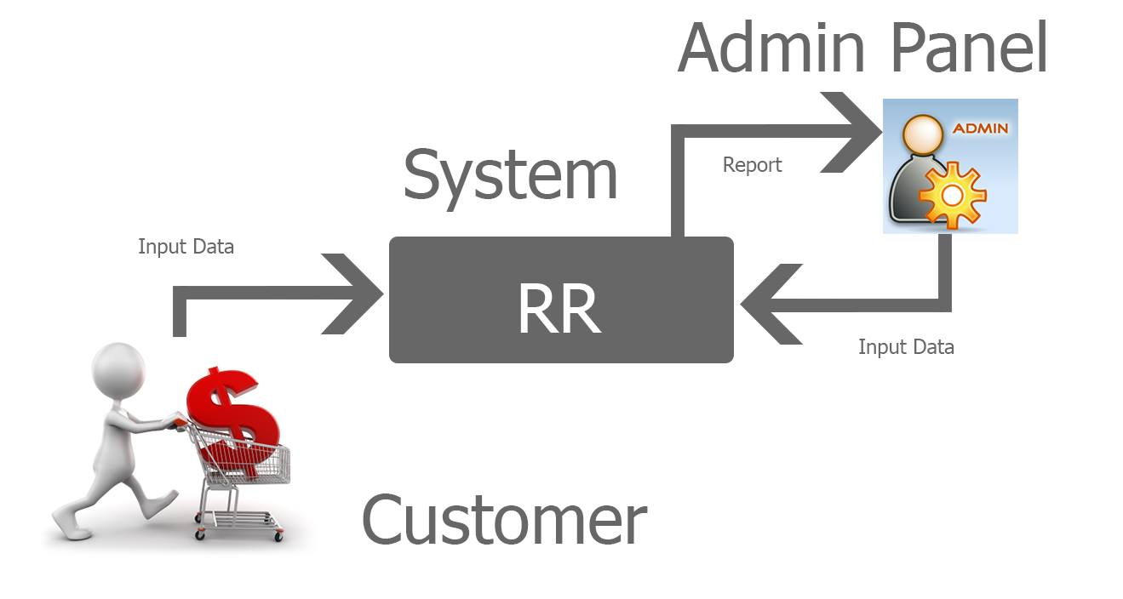

Figure (4) : Context Diagram

**3.3 Use case** :

The use case model shows the main system actors (people who interact directly with the system) to get her with the required functionalities of the proposed system. It also showed the interaction among the actors and the system. [8]

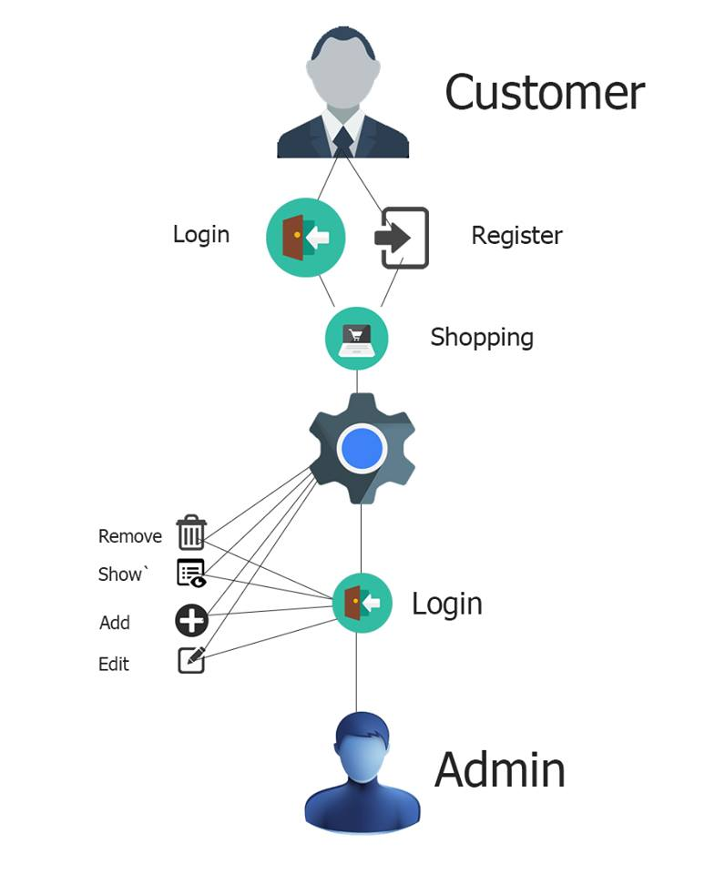

Figure (5 ) : Use case

**3.4 Data Model**

This is the table diagram of the system that shows all tables with attributes and the relation between them.[9]

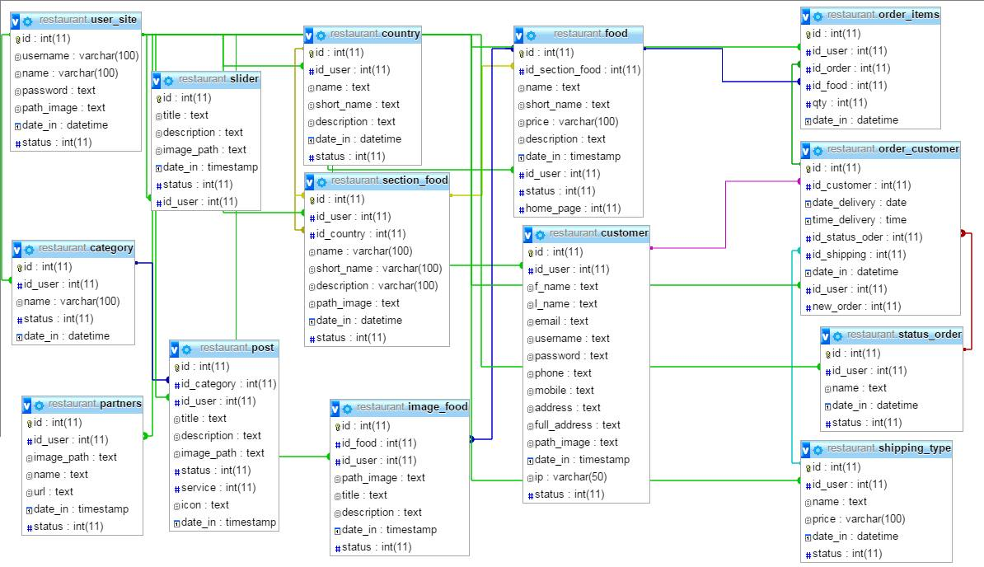

Figure (6 ) : Data model

**3.5 System Main Architecture**

The system architecture represents all external entities that may interact with the proposed system. It shows the hardware, software and user as depicted in figure(7). [10 ]

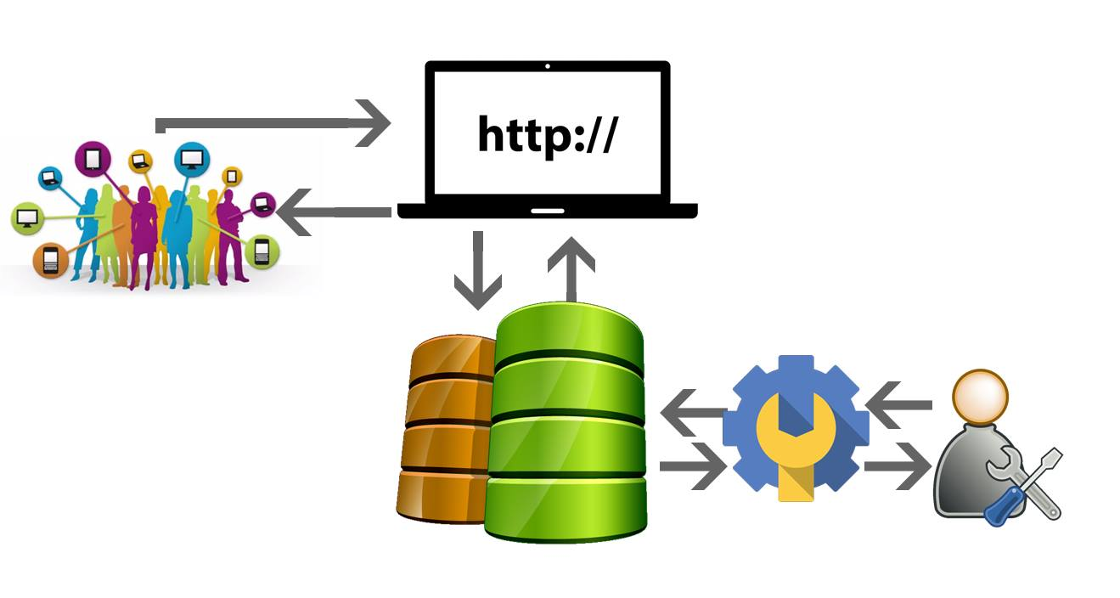

. Figure (7 ) : System Main Architecture

**CHAPTER FOUR**

In this section we show some of the interfaces that were designed at the site and used some of the tables in the database and how to create them.

**4.1 Database Table:-**

**1 ) Table of category :**

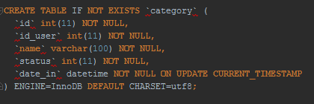

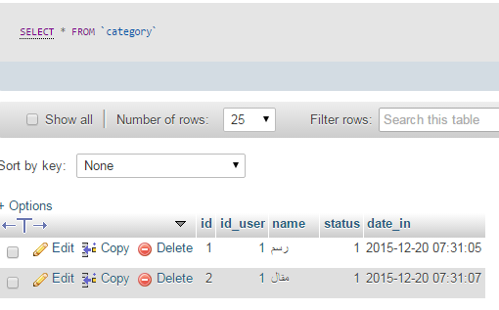

figure(8): Table of category

**2) table of country :**

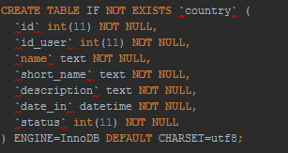

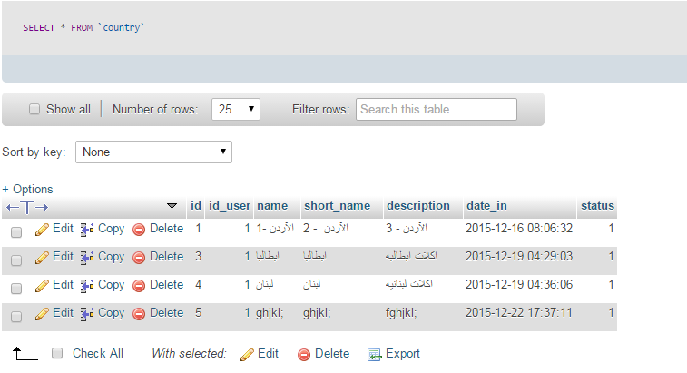

figure(9): Table of country

**3) table of customer :**

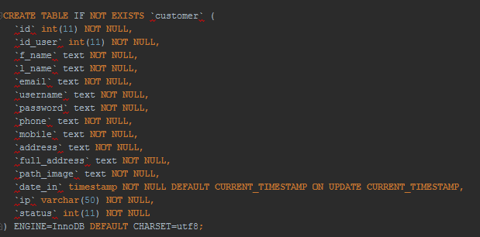

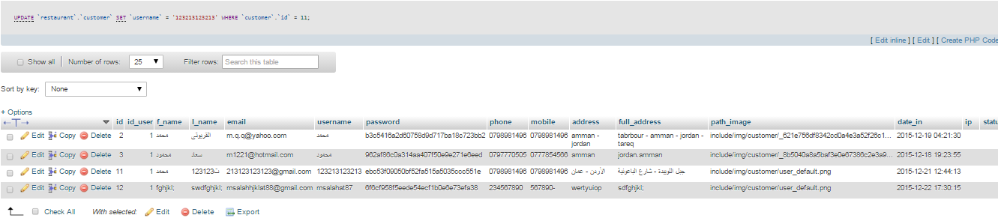

figure(10): Table of customer

**4) table of food :**

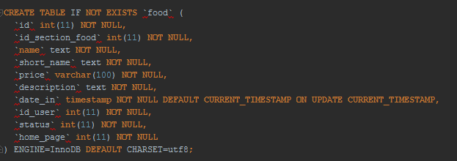

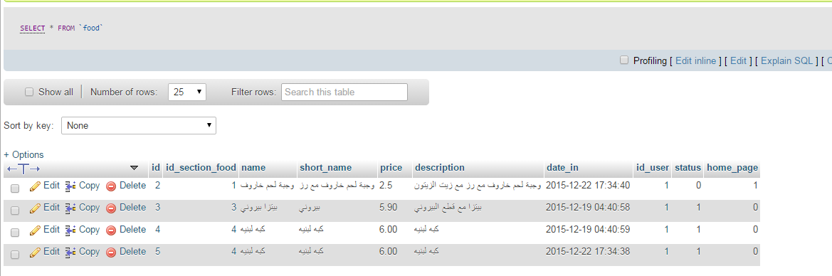

figure(11): Table of food

**5) table of image_food :**

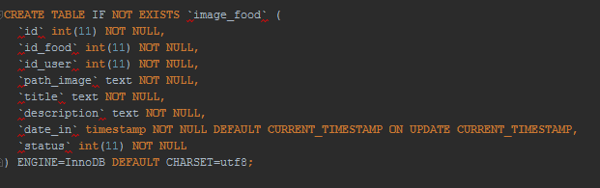

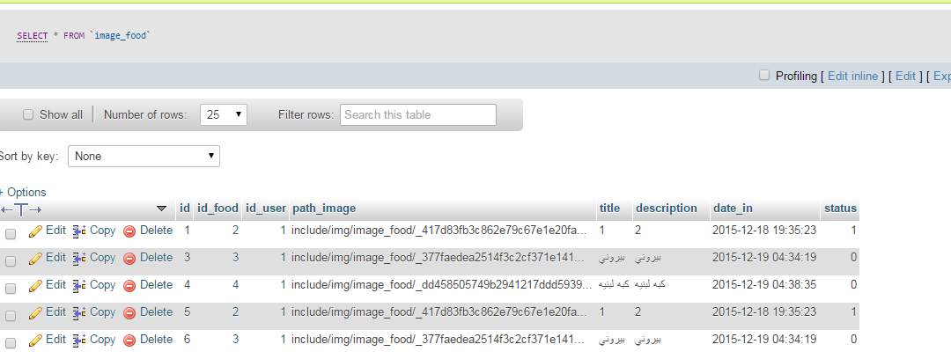

figure(12): Table of image_food

**6) table of order_customer :**

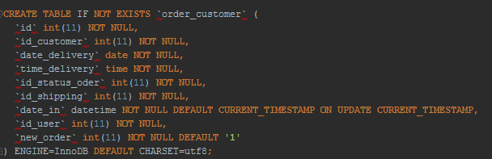

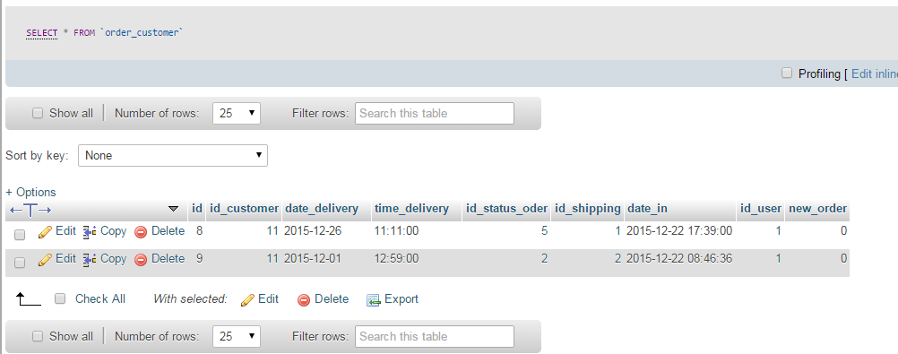

figure(13): **Table of order_customer**

**7) table of order_items :**

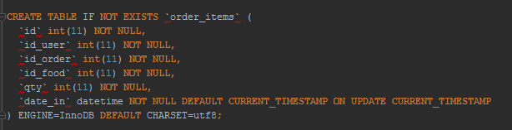

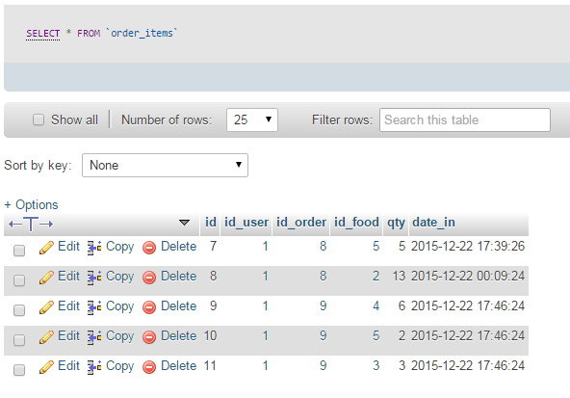

figure(14): Table of order_items

**8) table of partners :**

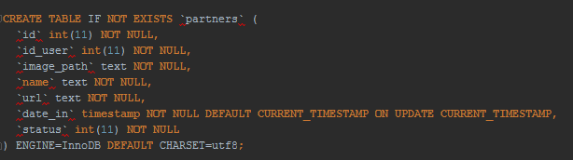

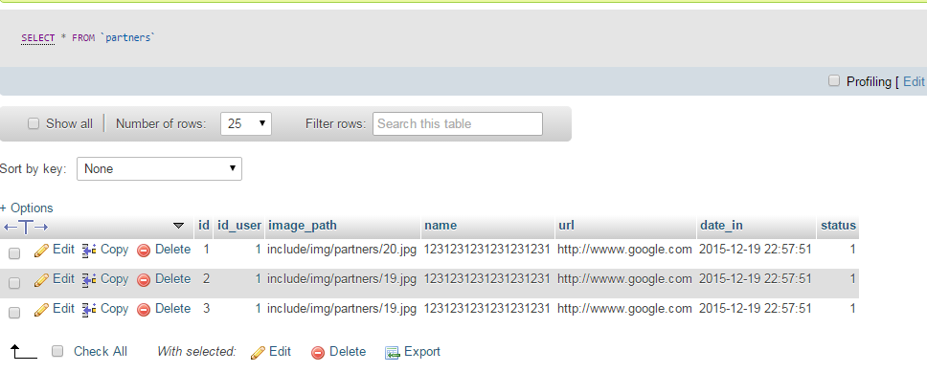

figure(15): Table of partners

**9) table of post :**

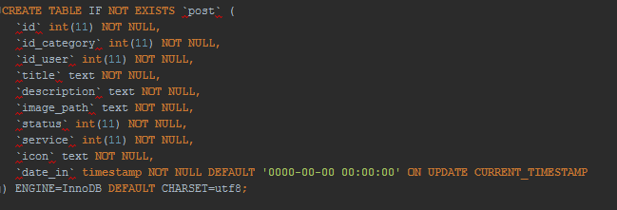

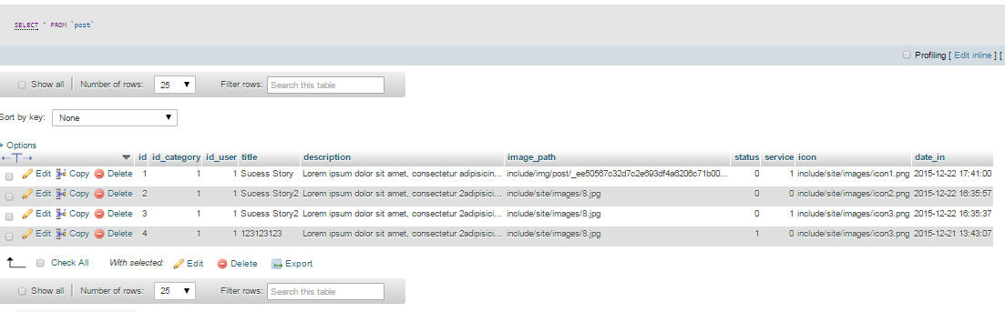

figure(16): Table of post

**10) table of section_food :**

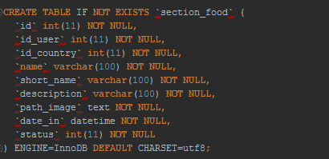

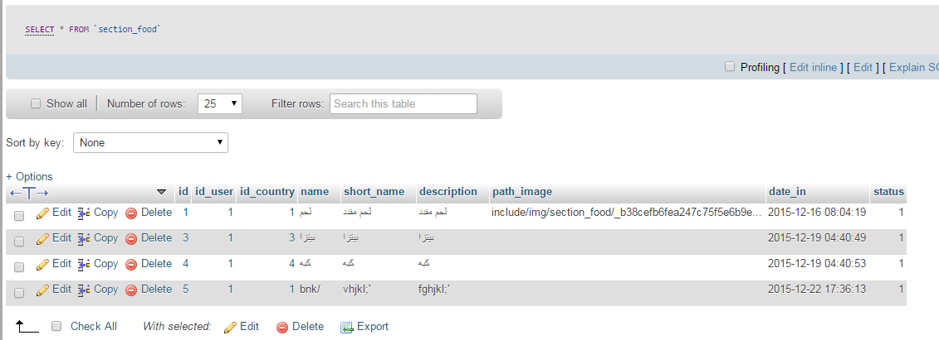

figure(17): Table of section_food

**11) table of shipping_type :**

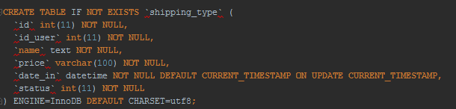

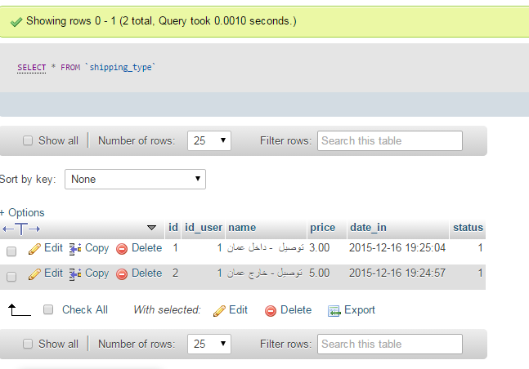

figure(18): Table of shipping_type

**12) table of slider :**

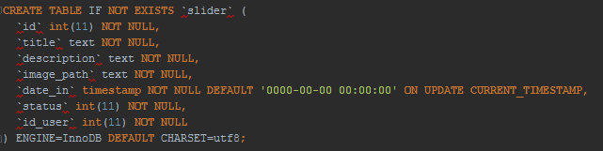

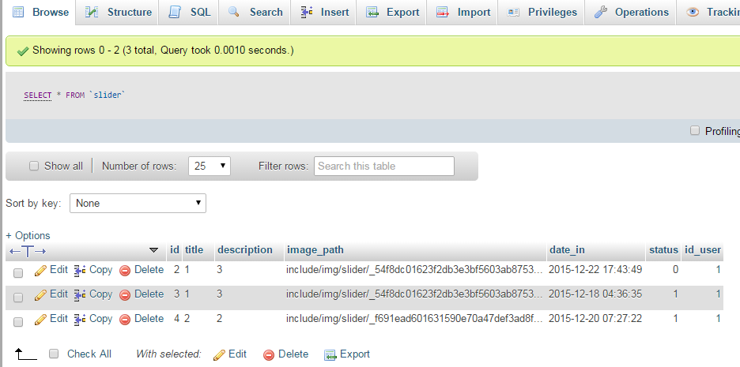

figure(19): Table of slider

**13) table of status_order :**

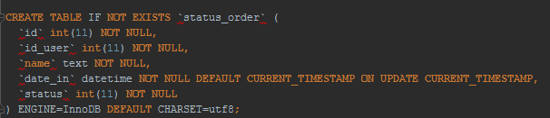

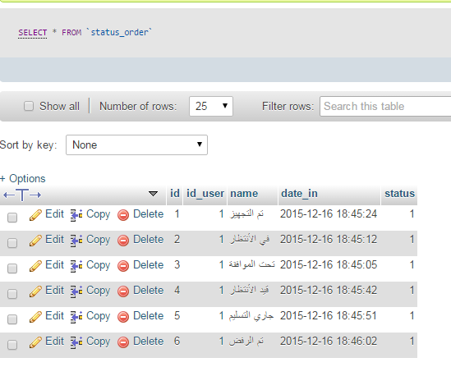

figure(20): Table of status_order

**14) table of user_site :**

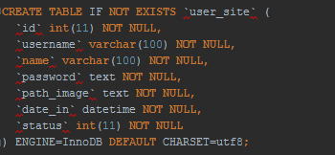

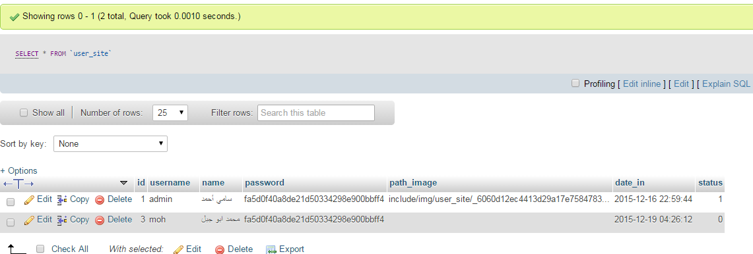

figure(21): Table of user_site

**4.2 Forms:-**

1 ) Home page : Is the first page for the user contains many features such as access to the site and lists of food and some services, counseling and Throwaway photos of dishes food

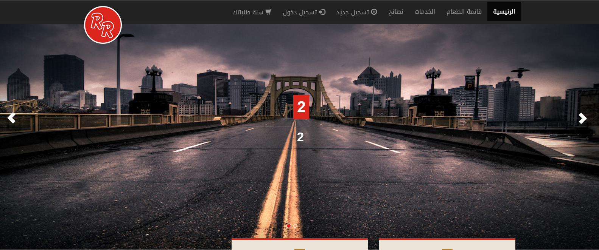

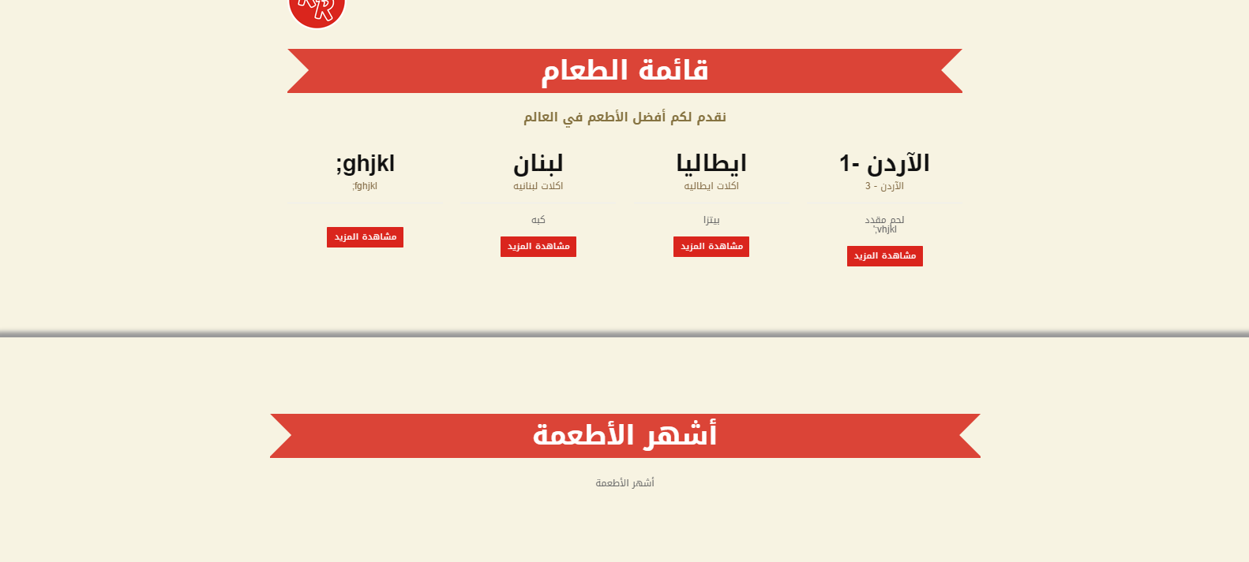

Figure (22) : Home page

2 ) Food menu : And where all food categories in terms of sections countries foods.

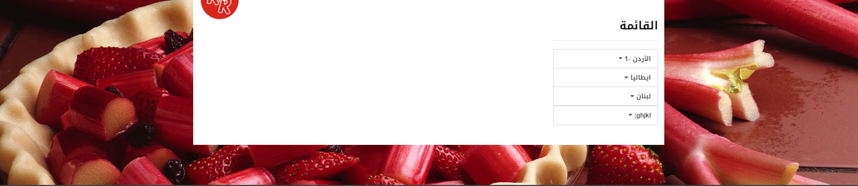

Figure (23) : Food menu

3 ) List Services : On this page you are viewing some of the existing services on the Website .

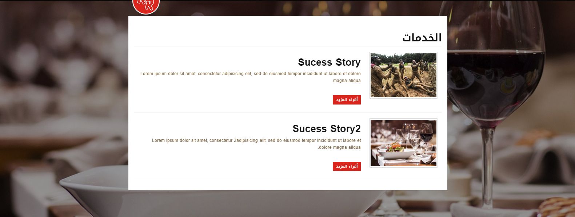

Figure (24) : List Services

4 ) List tips : On this page we offer some tips for meals and foods.

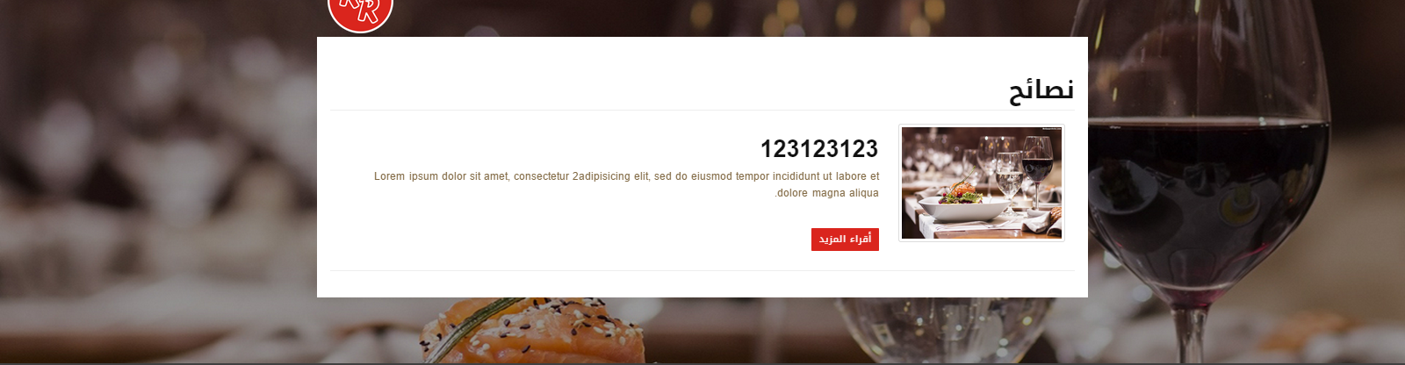

Figure (25) : List tips

5 ) New user registration page: The through this page to register a one-time only and the introduction of full data, in order to take advantage of the site's features.

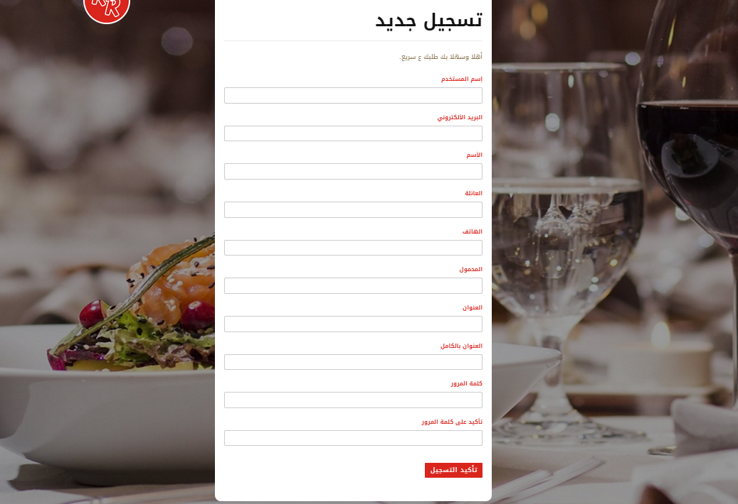

Figure (26) : registration page

6 ) Login page: From here the user enters after the registration process.

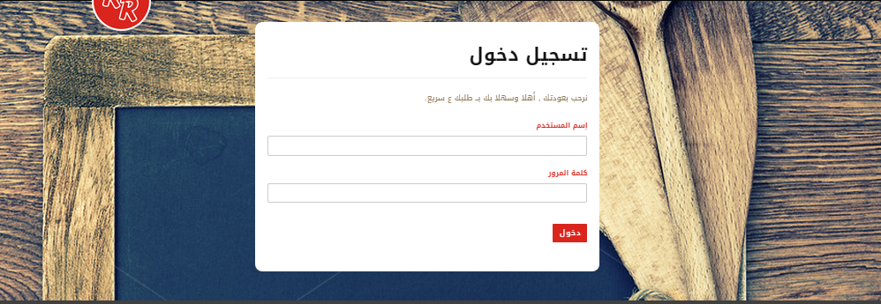

Figure (27) : Login page

6 ) Login admin page: From here the admin .

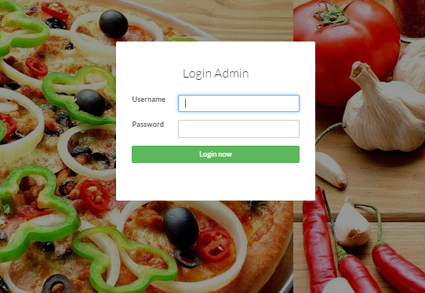

Figure (28) : Login admin page

7 ) Home page admin : It is the interface that appears to be the official explanation for all applications and complete its details and subdivisions .

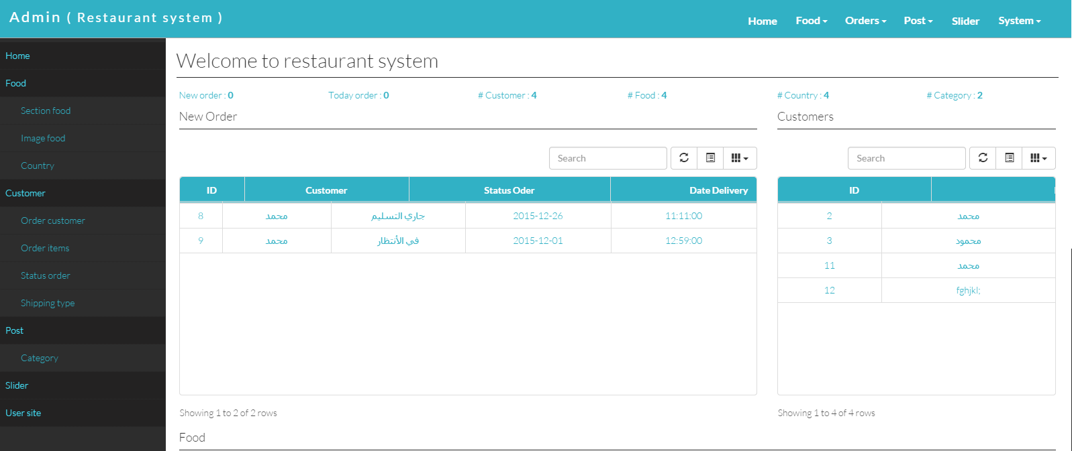

Figure (29) : Home page admin

8 ) Food page : A list of existing foods and some information about them was followed by a section in the absence provided by the administrator to cancel her appearance through the box situation and the administrator can add new foods through food .

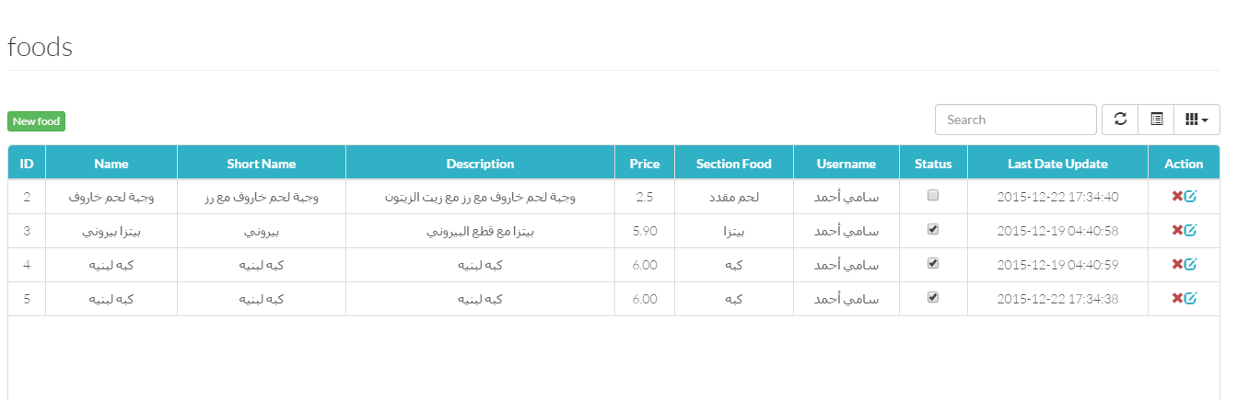

Figure (30) : food

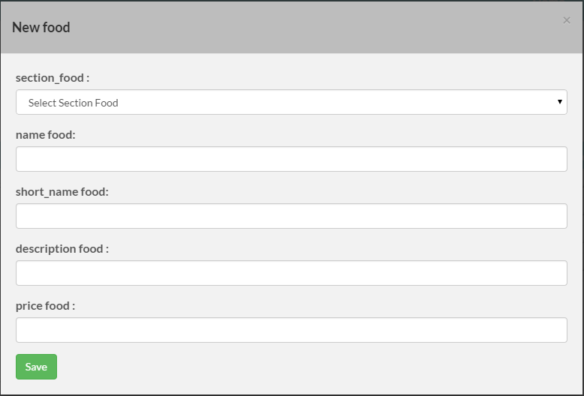

Figure (31) : new food

## 9) customers page : It shows the user through this page all customer data and can be added and modified on the list.

## 

Figure (32) : customers

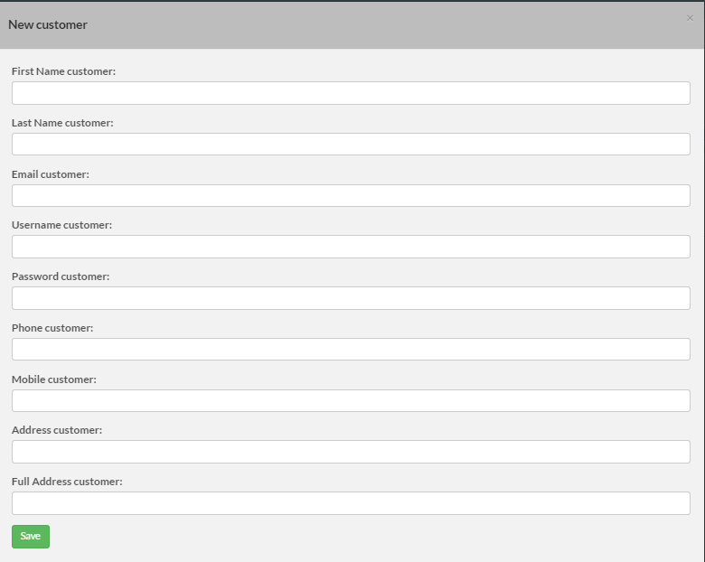

Figure (33) : new customers

## 10 ) posts : From this page the administrator to add comments and advice on the website and edited .

## 

Figure (34) : Post

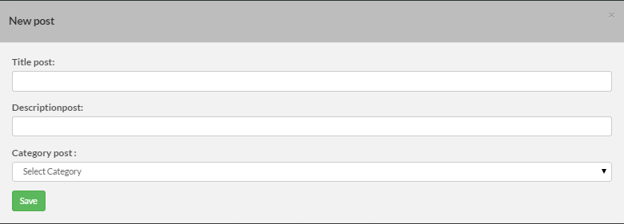

Figure (35) :New Post

## 11 ) order customers: From this page show the official requests and the status of orders requested by customers .

## 

Figure (36) : order customers

## 12 ) order_itemss : From this page show the official students as a type of food and classifications .

## 

Figure (37) : order_itemss

**CHAPTER FIVE**

**5.1 Conclusion**

After the completion of work and analysis and find advantages and problems and learn about the many sites and similar programs which summarized most of the problems in satisfying the customers and restaurant owners and provide ideal solutions to these problems in terms of speed, accuracy and ease of dealing with sites and with multiple devices and types of screens of computers and Tablet and Mobiles With different browsers which supports some programming languages ​​do not support each other and to find methods of attracting customers and explain to them all the expected outputs of the project so that it is distinctive for restaurant owners who are not finding all their demands and desires, which is the speed and find the output of reports and easily add and cancel meals and classification meals according to the characteristics of these foods.

After a lot of research, consulting and after some programmers consulted Dr. abd alsalam obidat we have to complete the project over four months and achieve all the expected goals of the project.

**5.2 Future Work** :

-Create an application on smart phones for all operating systems so that makes it easier for the customer to use the system.

- Make the site supports the characteristics of electronic payment to keep pace with technology developments.

Support for a dining table book on the site of the property in order to ease going to the restaurant.

-Send messages through the site or application to the customer about the latest offers from restaurants.

-Make available to the customer on the amendment dishes commensurate with the tastes.

**REFERENCES** :

1] <http://cgi.cse.unsw.edu.au/~kevine/thesisguide.html>

2] [http://www.talabat.com](http://www.talabat.com/)

3] <https://foodonclick.com/>

4] <https://www.zomato.com/ncr/foodzilla-sushant-lok-gurgaon>

5]<https://yuwritingcenter.wikispaces.com/How+to+Write+the+Methodology+of+a+Research+Paper>

6] <https://en.wikipedia.org/wiki/Functional_requirement>

7] <https://en.wikipedia.org/wiki/System_context_diagram>

8] <https://en.wikipedia.org/wiki/Use_case>

9] <https://en.wikipedia.org/wiki/Data_model>

10] <https://en.wikipedia.org/wiki/Systems_architecture>